Foods that Contain Pork
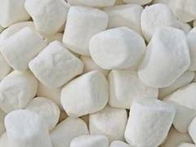

most kinds of marshmallows

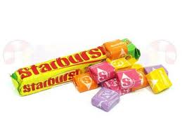

Starburst

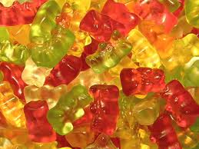
gummy bears

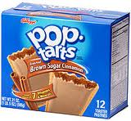
Some Pop Tarts (not all)

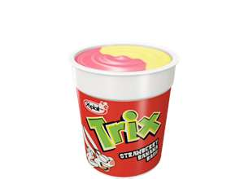
Foods that DO NOT contain pork

Yoplait Trix yogurt
(all Yoplait yogurts are OK)

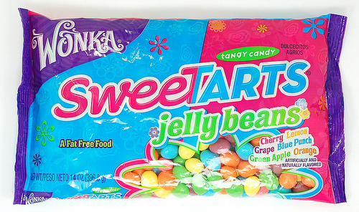

Wonka Sweetarts jellybeans

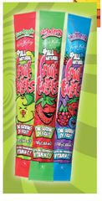
Sun Opta Frit Bars

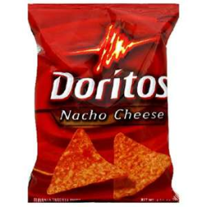
Doritos Nacho Cheese

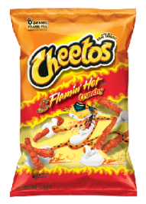

Flaming Hot Cheetos
Website for a list of Frito-Lay products that do not contain pork:
http://www.fritolay.com/your-health/us-products-made-without-porcine-enzymes.html

Look on the back of the product. If you see a ‘K’ or a ‘U’, it means it’s certified Kosher, and contains no pork.

